Lightning Release Notes

January 2023

As part of our commitment to continuous improvement, we are constantly developing and enhancing our technology and services along with listening to feedback from you, our important customers.

We are delighted to share some new functionality and enhancements which will be live in the system and available from **Tuesday 31st January 2023.**

We would be grateful if you could share this update with your bookers and travellers and if you have any feedback or suggestions, please get in touch with our Business Support team at [North.bsu@travelctm.com](mailto:North.bsu@travelctm.com)



New Features/Enhancements

Hotel – Map View Button Enhancement

Hotel results default to a list view, along with a Map View button which is highlighted below in Red. When the booker selects ‘map view’ a list of available hotels appears on a map, in accordance with the bookers search parameters.

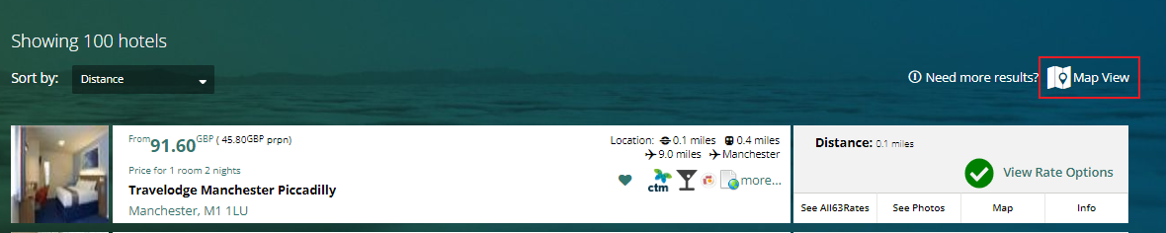

Rail – Specific Seat

Additional text has been added to the **Seat Reservation** section regarding bookers who select specific seats*.* If their selected seat is not available the following message will be displayed

*“If a requested seat is not available, then it will allocate the next seat closest to the bookers selection’'*

Hotel - Price Slider

On the hotel results page the option to filter using a price slider is now available. Using the price slider will update the results based on the price range selected. Please see below;

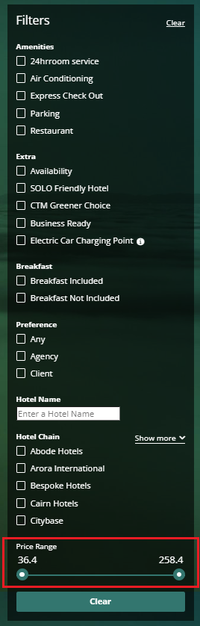

Changes

My Bookings – Ability to search for other user’s baskets

Admin Users can now search by user email within My Bookings > More Filters, to view the contents on their basket.

Add Guest Traveller – Error Handling

When adding a traveller as a guest if any of the fields are incomplete when the save button is selected the relevant error will appear on screen.

Taxi – Airport Terminal Information Mandatory

Taxi pick-up/drop-off including an airport will make the terminal information mandatory.